Welcome to Azure Cosmos DB

11

Tip

The Azure Cosmos DB DocumentDB API or SQL (DocumentDB) API is now known as Azure Cosmos DB SQL API. You don't need to change anything to continue running your apps built with DocumentDB API. The functionality remains the same.

Azure Cosmos DB is Microsoft's globally distributed, multi-model database. With the click of a button, Azure Cosmos DB enables you to elastically and independently scale throughput and storage across any number of Azure's geographic regions. It offers throughput, latency, availability, and consistency guarantees with comprehensive [service level agreements](https://aka.ms/acdbsla) (SLAs), something no other database service can offer. You can [Try Azure Cosmos DB for free](https://azure.microsoft.com/try/cosmosdb/) without an Azure subscription, free of charge and commitments.2

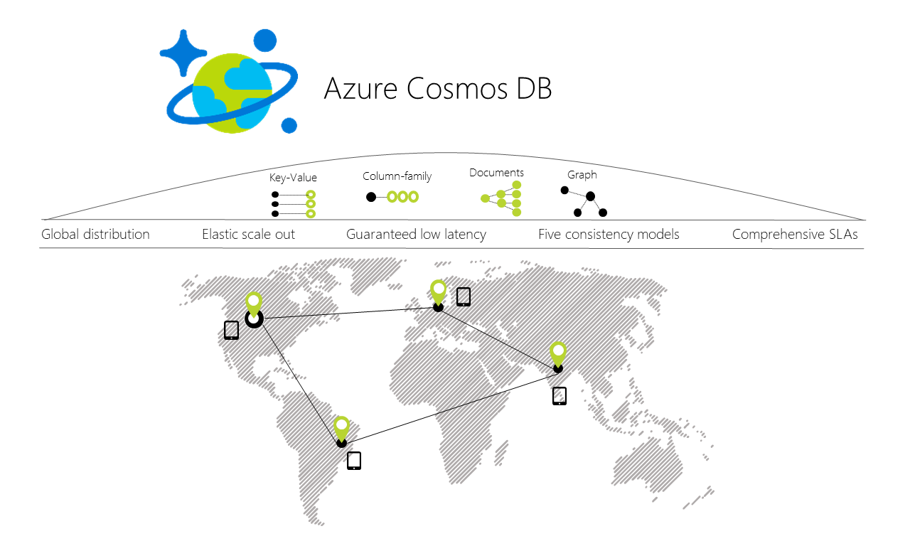

[Try Azure Cosmos DB for free](https://azure.microsoft.com/try/cosmosdb/)

Key capabilities

As a globally distributed database service, Azure Cosmos DB provides the following capabilities to help you build scalable, highly responsive applications:

* **Turnkey global distribution**
  + You can [distribute your data](https://docs.microsoft.com/en-us/azure/cosmos-db/distribute-data-globally) to any number of [Azure regions](https://azure.microsoft.com/regions/), with the [click of a button](https://docs.microsoft.com/en-us/azure/cosmos-db/tutorial-global-distribution-sql-api). This enables you to put your data where your users are, ensuring the lowest possible latency to your customers.
  + Using Azure Cosmos DB's multi-homing APIs, the app always knows where the nearest region is and sends requests to the nearest data center. All of this is possible with no config changes. You set your write-region and as many read-regions as you want, and the rest is handled for you.
* **Multiple data models and popular APIs for accessing and querying data**
  + The atom-record-sequence (ARS) based data model that Azure Cosmos DB is built on natively supports multiple data models, including but not limited to document, graph, key-value, table, and columnar data models.
  + APIs for the following data models are supported with SDKs available in multiple languages:
    - [SQL API](https://docs.microsoft.com/en-us/azure/cosmos-db/documentdb-introduction): A schema-less JSON database engine with SQL querying capabilities.
    - [MongoDB API](https://docs.microsoft.com/en-us/azure/cosmos-db/mongodb-introduction): A MongoDB database service built on top of Cosmos DB. Compatible with existing MongoDB libraries, drivers, tools and applications.
    - [Table API](https://docs.microsoft.com/en-us/azure/cosmos-db/table-introduction): A key-value database service built to provide premium capabilities for Azure Table storage applications.
    - [Graph (Gremlin) API](https://docs.microsoft.com/en-us/azure/cosmos-db/graph-introduction): A graph database service built following the [Apache TinkerPop specification](http://tinkerpop.apache.org/).
    - [Cassandra API](https://docs.microsoft.com/en-us/azure/cosmos-db/cassandra-introduction): A key/value store built on the [Apache Cassandra](https://cassandra.apache.org/)implementation.
    - Additional data models coming soon!
* **Elastically scale throughput and storage on demand, worldwide**
  + Easily scale database throughput at a [per-second](https://docs.microsoft.com/en-us/azure/cosmos-db/request-units) granularity, and change it anytime you want.
  + Scale storage size [transparently and automatically](https://docs.microsoft.com/en-us/azure/cosmos-db/partition-data) to handle your size requirements now and forever.
* **Build highly responsive and mission-critical applications**
  + Azure Cosmos DB guarantees end-to-end low latency at the 99th percentile to its customers.
  + For a typical 1-KB item, Cosmos DB guarantees end-to-end latency of reads under 10 ms and indexed writes under 15 ms at the 99th percentile, within the same Azure region. The median latencies are significantly lower (under 5 ms).
* **Ensure "always on" availability**
  + 99.99% availability SLA for all single region accounts and all multi-region accounts with relaxed consistency, and 99.999% read availability on all multi-region database accounts.
  + Deploy to any number of [Azure regions](https://azure.microsoft.com/regions) for higher availability.
  + [Simulate a failure](https://docs.microsoft.com/en-us/azure/cosmos-db/regional-failover) of one or more regions with zero-data loss guarantees.
* **Write globally distributed applications, the right way**
  + Five [consistency models](https://docs.microsoft.com/en-us/azure/cosmos-db/consistency-levels) models provide a spectrum of strong SQL-like consistency all the way to NoSQL-like eventual consistency, and every thing in between.
* **Money back guarantees**
  + Your data gets there fast, or your money back.
  + [Service level agreements](https://aka.ms/acdbsla) for availability, latency, throughput, and consistency.
* **No database schema/index management**
  + Stop worrying about keeping your database schema and indexes in-sync with your application’s schema. We're schema-free.
  + Azure Cosmos DB’s database engine is fully schema-agnostic – it automatically indexes all the data it ingests without requiring any schema or indexes and serves blazing fast queries.
* **Low cost of ownership**
  + Five to 10 times [more cost effective](https://aka.ms/cosmos-db-tco-paper) than a non-managed solution.
  + Three times cheaper than DynamoDB.

Capability comparison

Azure Cosmos DB provides the best capabilities of relational and non-relational databases.

| Capabilities | Relational databases | Non-relational (NoSQL) databases | Azure Cosmos DB |
| --- | --- | --- | --- |
| Global distribution | No | No | Yes, turnkey distribution in 30+ regions, with multi-homing APIs |
| Horizontal scale | No | Yes | Yes, you can independently scale storage and throughput |
| Latency guarantees | No | Yes | Yes, 99% of reads in <10 ms and writes in <15 ms |
| High availability | No | Yes | Yes, Cosmos DB is always on, has PACELC tradeoffs, and provides automatic & manual failover options |
| Data model + API | Relational + SQL | Multi-model + OSS API | Multi-model + SQL + OSS API (more coming soon) |
| SLAs | Yes | No | Yes, comprehensive SLAs for latency, throughput, consistency, availability |

Solutions that benefit from Azure Cosmos DB

Any [web, mobile, gaming, and IoT applications](https://docs.microsoft.com/en-us/azure/cosmos-db/use-cases) that need to handle massive amounts of reads and writes on a [global](https://docs.microsoft.com/en-us/azure/cosmos-db/distribute-data-globally) scale with low response times for a variety of data will benefit from Azure Cosmos DB's [guaranteed](https://azure.microsoft.com/support/legal/sla/cosmos-db/) availability, high throughput, low latency, and tunable consistency. Learn about how CosmosDB can be applied to [IoT and telematics](https://docs.microsoft.com/en-us/azure/cosmos-db/use-cases" \l "iot-and-telematics), [Retail and marketing](https://docs.microsoft.com/en-us/azure/cosmos-db/use-cases#retail-and-marketing), [Gaming](https://docs.microsoft.com/en-us/azure/cosmos-db/use-cases#gaming) and [Web and mobile applications](https://docs.microsoft.com/en-us/azure/cosmos-db/use-cases#web-and-mobile-applications).